**ADF Investigations: MFA User Guide – Browser Extension**

**(2-Step verification /** **authentication - 2FA)**

**Initial Setup**

The instructions below are for using MFA (aka 2-Step Verification) with a computer and a browser extension (<https://en.wikipedia.org/wiki/Browser_extension>).

**ATTENTION:** These instructions are for initial setup only. If you already followed these instructions, but deleted your MFA account on your browser extension, then you must contact the IT help desk (888-233-6285) to reset your MFA account on the ADF web server. **IT admin tip:** Open “ID Vault” in IBM_ID_VAULT folder via HCAA client, select user and click Actions - Reset TOTP items.

1. Install a TOTP browser extension, for example, authenticator (<https://authenticator.cc>).
2. Open website: [www.adfinvestigations.com](http://www.adfinvestigations.com)
3. Click a button below to login as needed.

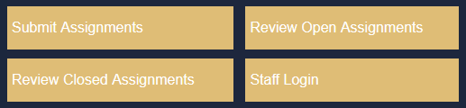

1. If you did **not** setup a MFA account for ADF on your smartphone or another computer (or the IT help desk reset your MFA account), then skip to the step 5, otherwise, follow the steps below.
   1. Login with your User name, Password and type MFA code displayed in your authenticator app in the MFA Token field, then click the “Set up Multi Factor Authentication” button as seen below.

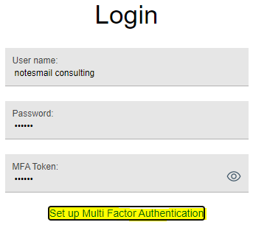

* 1. Click “Configure another account…” as seen below.

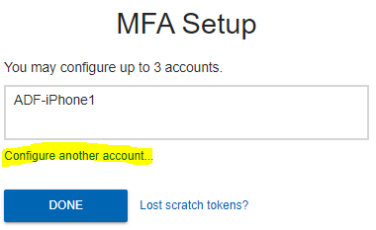

* 1. Click “DONE” button, then skip to step 6.

1. Enter your user name and password, then click ”Set up Multi Factor Authentication”. Note: If you enter your wrong password 5x in a row you will be locked out for 10 minutes.

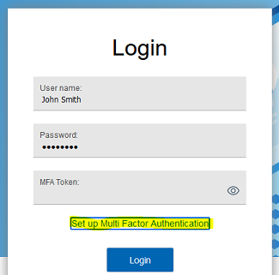

1. Type, for example, “ADF-Computer1” in the MFA Setup prompt and click OK as seen in screenshot below. Note: If you plan to setup MFA on multiple devices you might want to type, for example, “ADF-Computer1”, “ADF-Phone1”, “ADF-Tablet1”, etc.

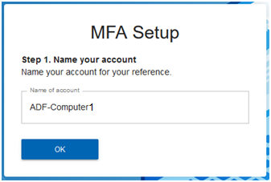

1. Ignore the QR Code! Copy the TOTP URI by clicking the copy icon depicted by the yellow pointing arrow as seen below. Paste it into the body of an email and send it to yourself. Note: You can use the same TOTP URI to setup the authenticator browser extension on multiple browsers and / or computers.

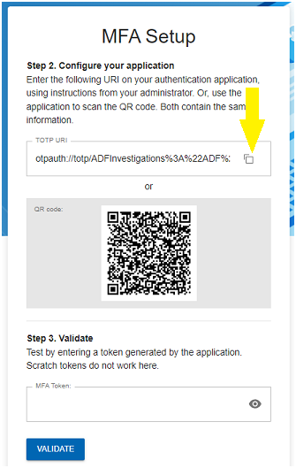

1. Open the email you sent which displays the TOTP URI, then copy the "secret" highlighted in yellow as seen below. The secret code will be different for every MFA account. Carefully copy the code that is in between the "secret=" and "&issuer=". Highlight the code with your mouse and press Control+C on Windows or Command+C on Mac to copy the value to the computer's clipboard.

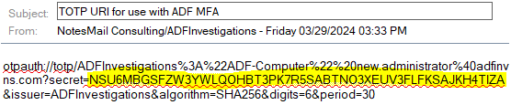

1. Click the extension icon in the upper right corner of your browser as seen below.
   1. Click the authenticator browser extension (looks like a small QR code) as seen below which you installed in step #1 above (<https://authenticator.cc>).
   2. Click on the pencil / edit icon as seen below.
   3. Click on the + icon to add a new account.
   4. Click on Manual Entry.
   5. Enter an issuer name (i.e. ADF-Computer1), then click into the Secret field and press Control+V on windows or Command+V on Mac to paste the MFA secret value into the field. Click OK.
   6. Click on the MFA token code to copy it to the clipboard as seen below.

 

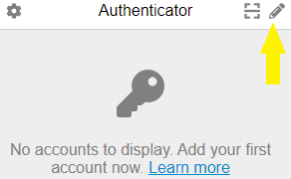 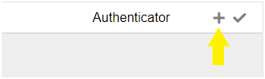

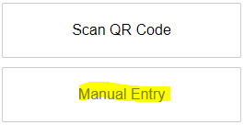 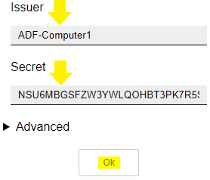

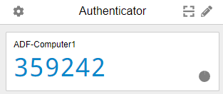

1. Paste the MFA token code from the clipboard into the MFA Token field, then click the “VALIDATE” button as seen below.

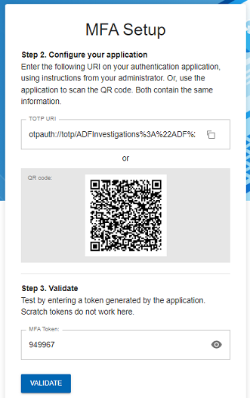 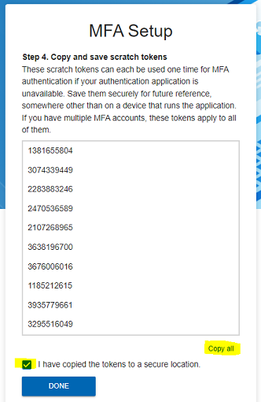

1. Click “Copy all” and the checkbox , then click the “DONE” button as seen above. Click “DONE” if you see the prompt below which will display if you created more than one MFA account. Note: Optionally, you can create a new email & paste the codes, then send it to yourself and/or paste the codes in Word or Notepad and save it for later use in an emergency – meaning you lost your computer (or it was factory reset) and you need to quickly login and use a code without contacting the IT help desk (888-233-6285) to reset your MFA account on the ADF web server.

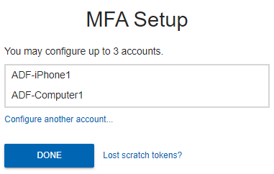

1. Login with your User name, Password and paste code displayed in your authenticator browser extension in the MFA Token field, then click the “Login” button as seen below.

