**ADF Investigations: MFA User Guide - Mobile**

**(2-Step verification /** **authentication - 2FA)**

**Initial Setup**

The instructions below are for the most common way to use MFA (aka 2-Step Verification) with a computer and a mobile device such as your smartphone. For example, you might use 2-Step Verification with Gmail which requires you to enter a code which is sent to your smartphone.

**ATTENTION:** These instructions are for initial setup only. If you already followed these instructions, but deleted your MFA account on your mobile device, then you must contact the IT help desk (888-233-6285) to reset your MFA account on the ADF web server. **IT admin tip:** Open “ID Vault” in IBM_ID_VAULT folder via HCAA client, select user and click Actions - Reset TOTP items.

1. Open website: [www.adfinvestigations.com](http://www.adfinvestigations.com)
2. Click a button below to login as needed.

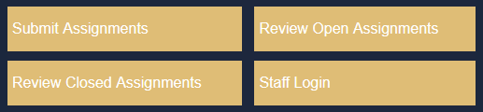

1. Enter your user name and password, then click ”Set up Multi Factor Authentication”. Note: If you enter your wrong password 5x in a row you will be locked out for 10 minutes.

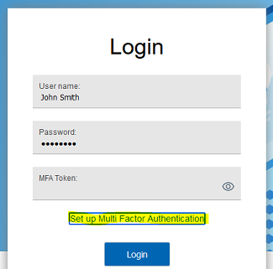

1. Type, for example, “ADF-Phone1” in the MFA Setup prompt and click OK as seen in screenshots below. After you click OK you will see a prompt with a QR code, but don’t take further action until you follow steps 5 thru 7 below. Note: If you plan to setup MFA on multiple devices you might want to type, for example, “ADF-Phone1”, “ADF-Tablet1”, “ADF-Computer1”, etc.

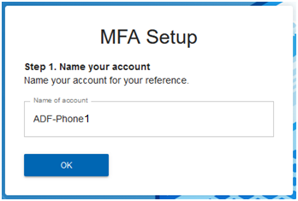

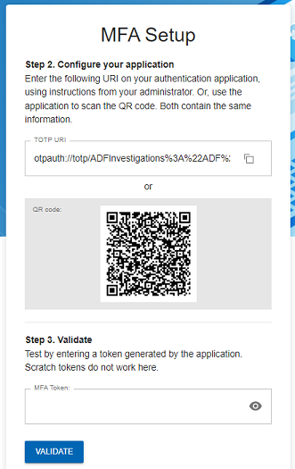

1. Download an authenticator app, for example, “Microsoft Authenticator “on your smartphone. If you already have it installed, then skip to step 6.



**Apple App Store:**

<https://apps.apple.com/us/app/microsoft-authenticator/id983156458>

**Google Play:**

<https://play.google.com/store/apps/details?id=com.azure.authenticator&hl=en_US&gl=US>

1. Open “Authenticator” app on your smartphone and follow instructions. Tap the plus (+) sign when you see the Accounts screen, then tap “Other (Google, Facebook, etc.)” as seen below.

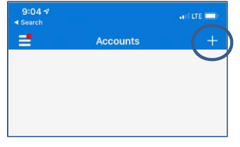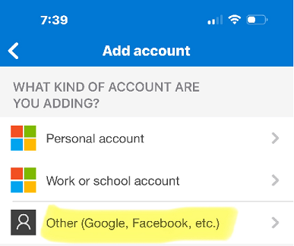

1. When you see the Scan QR code screen as seen below scan the QR code on your computer screen. This will create a MFA account which displays a number code as seen below.

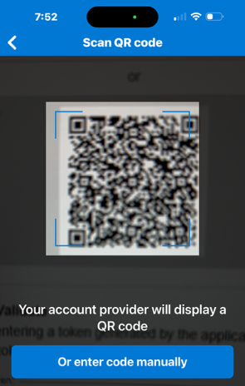 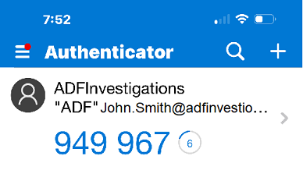

1. Enter the number displayed in the Authenticator app in the MFA Token box on your computer screen, then click the “VALIDATE” button as seen below.

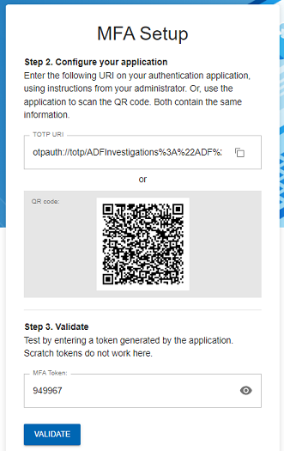 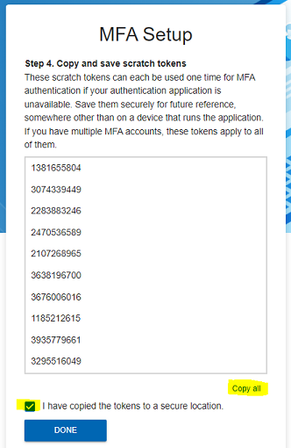

1. Click “Copy all” and the checkbox , then click the “DONE” button as seen above. Note: Optionally, you can create a new email & paste the codes, then send it to yourself and/or paste the codes in Word or Notepad and save it for later use in an emergency – meaning you lost your mobile device (or it was factory reset) and you need to quickly login and use a code without contacting the IT help desk (888-233-6285) to reset your MFA account on the ADF web server.
2. Login with your User name, Password and type the code displayed in your authenticator app in the MFA Token field, then click the “Login” button as seen below.

